Add Kelley Create Email Signature in Outlook

Download this document and enable editing.

- Open Outlook, go to File tab > Options
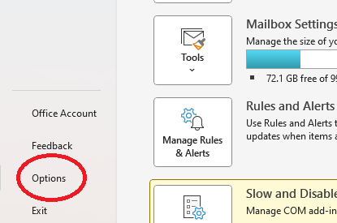
- Select “Mail” on the left, then select “Signatures...”
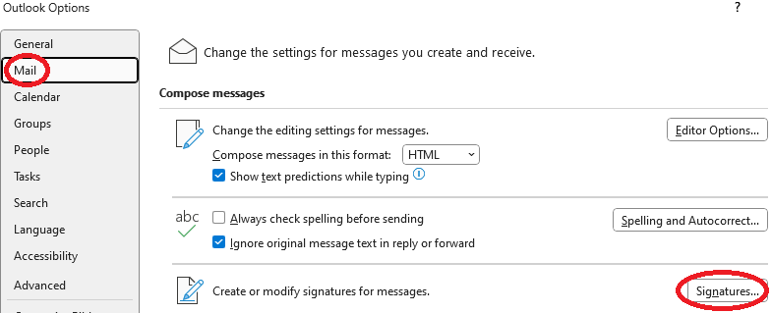
- Select “New“
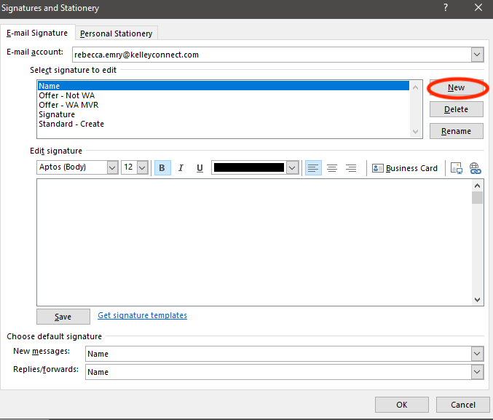
- Give the signature a name. Select “OK” when done.
- Under the “Choose default signature“ area, select the “E-mail account” Name of the signature in the “New messages” and/or “Replies/forwards” fields.
- Within the “Edit signature” area, select the “return” key twice and copy and paste this new signature, revising your name, title, mobile (m), and office (o) phone numbers. You’ll need to single-click on the Kelley Create logo image, then copy and paste it into your signature.



[Enter Your Name]
[Enter Your Title]

c 123 123-4567
o 123 123-4567
kelleycreate.com

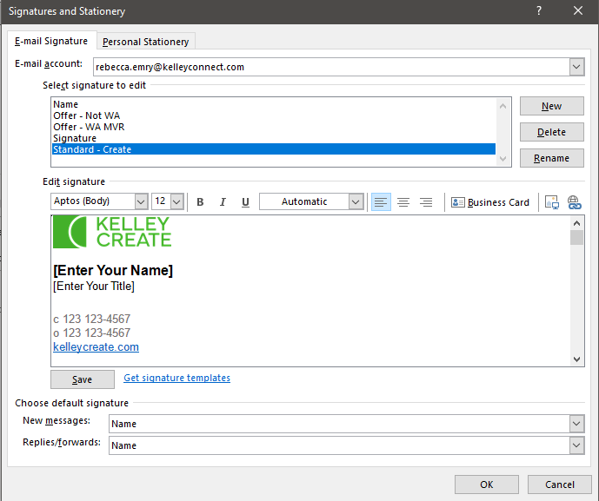

- Select OK. It’s recommended you send a test email to yourself to confirm it’s been applied.

If you still need help, please contact the KelleyHelpDesk@kelleycreate.com or marketing@kelleycreate.com.

